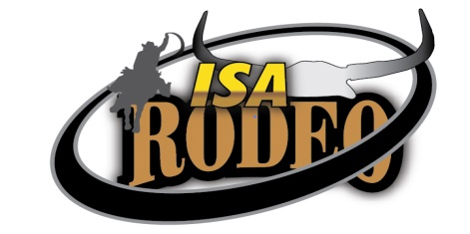

ISA RODEO
VOLUNTEER CODE OF CONDUCT
ACKNOWLEDGEMENT

I acknowledge that in volunteering at the Isa Rodeo I am representing my Community Group and the Isa Rodeo and will do my best to act in a manner that will reflect well on both organisations.
I acknowledge my responsibility to:

- Be courteous in my dealings with the public, other volunteers and Isa Rodeo representatives;
- Use my best endeavours to carry out the tasks allocated to me in a competent and pleasant manner;
- Refrain from acting in a manner that could cause offence and/or injure the reputation of the Isa rodeo, or the Community Group for whom I am volunteering;
- Act honestly and ethically;
- Follow the instructions given to me by my Community Group Liaison person or representatives of Isa Rodeo, including the Isa Rodeo Volunteer Coordinator.

............................................................................... .................................................... ……………………
Name Signature Date

The Isa Rodeo acknowledges and is grateful for the work done by the Community Groups and volunteers such as yourself both for the community of Mount Isa and on behalf of your Community Group during the Isa Rodeo.
We want to ensure that the Isa Rodeo is an enjoyable and safe event for the public and for all our volunteers, staff and contractors. This is why we ask you to undertake an Induction before working at the Isa Rodeo, and also why we are asking all volunteers to agree to these conduct standards.
We know that from time to time you may have to deal with members of the public who are rude or aggressive and we ask that you act with courtesy and restraint in your response if this occurs.
If you observe any behaviours that you believe are unlawful, that you are concerned may cause a workplace health and safety issue and/or could result in anyone being harmed, including aggressive behaviours, please immediately contact your Community Group’s Liaison Person, the Isa Rodeo Volunteer Co-Ordinator or a member of Isa Rodeo staff.

